Product Design
Team | ☺

Revision Number | Revision Date | Summary of Changes | Author(s)
1.0 | 10/14/2016 | Created Class Design | Joshua Tews

Class Diagram(s) 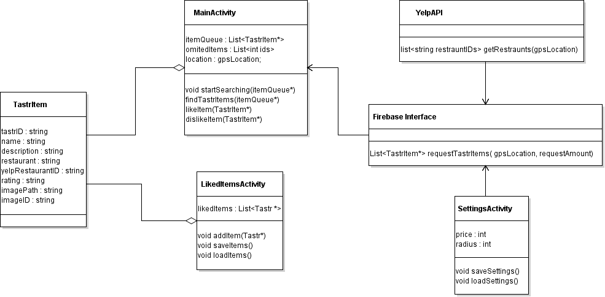

Design Summary
The diagram uses the firbase class as the main interface to our tastr items. It uses the yelpAPI and the settings to build a list of TastrItems. This list is stored and showed to the user. The user then selects to like or dislike the item. If the item is liked, it is saved and if it is disliked, it is removed from the queue and put into the omitedItems list. The omitted items list is used to not show duplicates. The liked item activity saves the items on the phone the same way the settings are saved on the phone.

Design Rationale
For a more clean main activity we can create a single findItems() function that hides all the api. This will allow us to focus on the UI or other useful features of the main activity without cluttering it up. We are using a tastr Item class that is saved on firebase and can be pulled if it matches the criteria. This allows us to add components to our items with later updates and it will easily apply to all items. Additionally, the settings can be updated and because of their direct link with the firebase function we can directly access setting instead of trying to pass settings through functions, making it easier to implement new settings and forms of filtering. Lastly, the Omitted Items list is used to keep from showing items the user has liked before, disliked in the current session, or has manually filtered. It will be emptied after each session as user’s taste may change but will be reinitialized when startSearching() is called.

